**Safety Gadget for Child Safety Monitoring and Notification**

**IBM NALAIYATHIRAN**

**Project Development –Delivery of Sprint 1**

**Creating and Connecting IBM cloud for Project and Python Code**

|  |  |
| --- | --- |
| **TITLE** | IOT based child safety gadget for child safety monitoring and notification |
| **DOMAIN NAME** | INTERNET OF THINGS |
| **TEAM ID** | PNT2022TMID50609 |
| **TEAM LEADERNAME** | SELSHIA M |
| **TEAM MEMBER**  **NAME** | BANUPRIYA K  SANDHIYA SUBASHREE M  SUBHASHINI G |
|  |  |

**Creating IBM Cloud Service and creating the device:**

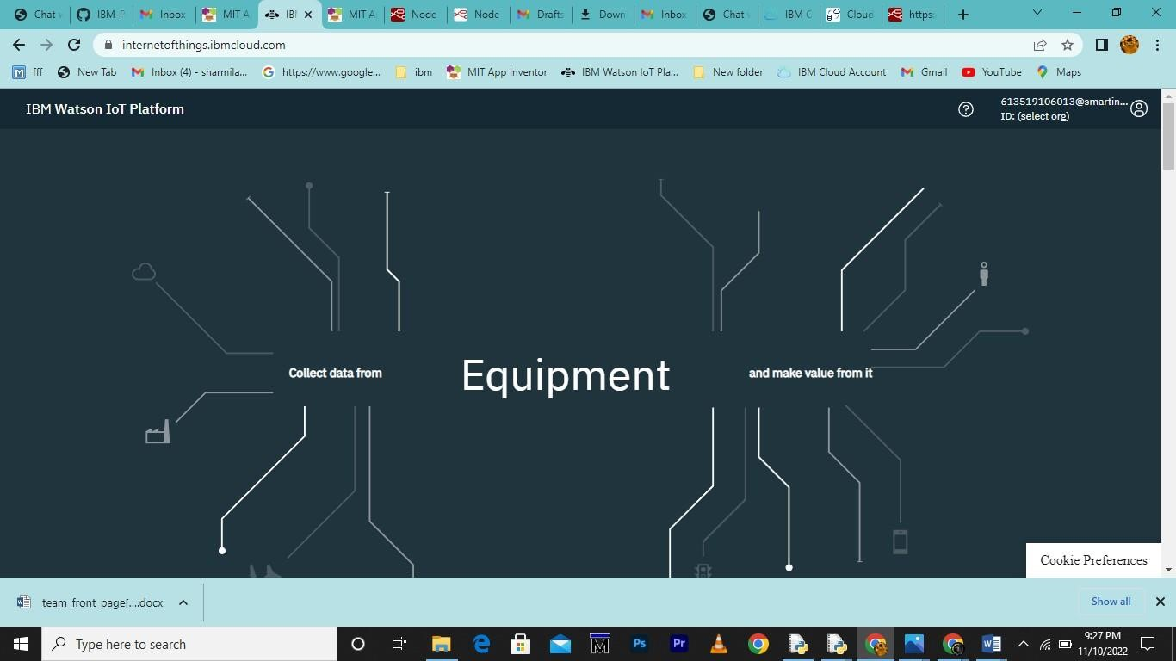

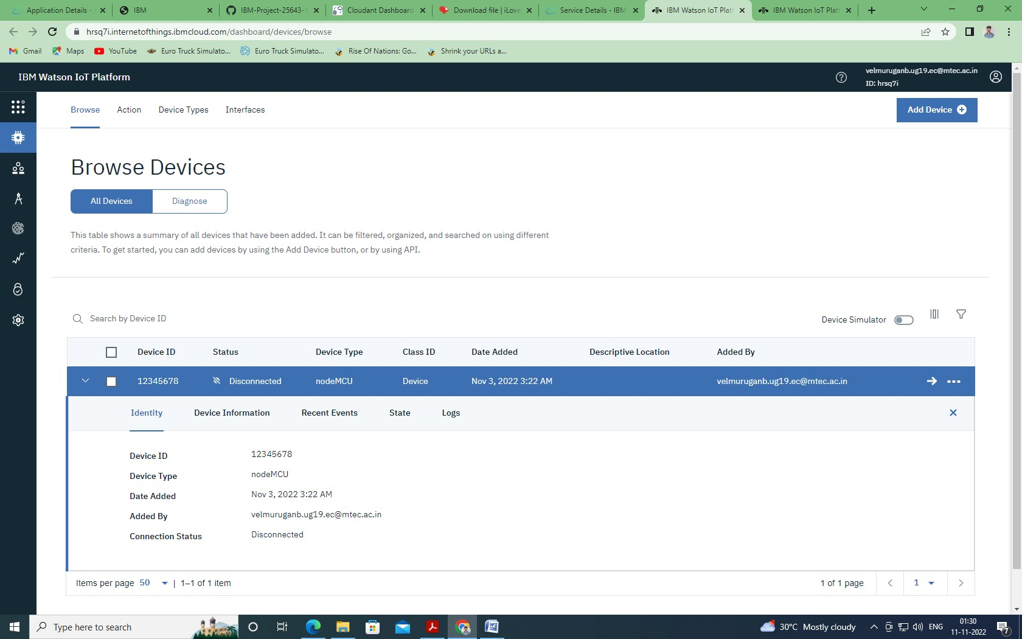

**Creating Python Code:**

import time import sys

import ibmiotf.application import ibmiotf.device import random

#Provide your IBM Watson Device Credentials organization = "zwx6lb" deviceType="nodeMCU" deviceId = "12345678" authMethod = "token" authToken = "12345678"

#api key {a-illza1-mbdxqo6z0s}

#api token {zSYzISuAWF&F_x7GkT}

try:

deviceOptions = {"org": organization, "type": deviceType, "id": deviceId, "auth-method":

authMethod, "auth-token": authToken} deviceCli = ibmiotf.device.Client(deviceOptions)

#.............................................. except Exception as e:

print("Caught exception connecting device: %s" % str(e)) sys.exit()

# Connect and send a datapoint "hello" with value "world" into the cloud as an event of type

"greeting" 10 times print("power on ") print("checking connection to waston iot...") time.sleep(2) deviceCli.connect()

print("dear user ... welcome to IBM-IOT ")

print("i can provide your children live location and temperature ") print()

name=str(input("enter your child name:")) while True:

temperature=random.randint(20,50)#random temperature for your child latitude=random.uniform(10.781377,10.78643)#random latitude for your child longitude=random.uniform(79.129113,79.134014)#random longitude for your child a="Child inside the geofence" b=" Child outside the geofence" c="High temperature" d="Low temperature" x={'your_child_Zone':a} y={'your_child_Zone':b} z={'temp_condition':c} w={'temp_condition':d}

data = { 'temp' : temperature, 'lat': latitude,'lon':longitude,'name':name }

#print data def myOnPublishCallback(): print ("Published Temperature = %s C" % temperature, "latitude = %s %%" % latitude,

"longitude = %s %%" % longitude, "to IBM Watson") print("\n")

success = deviceCli.publishEvent("IoTSensorgpsdata", "json", data, qos=0,

on_publish=myOnPublishCallback) if latitude>=10.78200 and latitude<=10.786000 and longitude >=79.130000 and longitude

<=79.133000:

deviceCli.publishEvent("IoTSensorgpsdata","json",data=x,qos=0,on_publish=myOnPublishCallb ack)

print(x) print("\n")

else:

deviceCli.publishEvent("IoTSensorgpsdata","json",data=y,qos=0,on_publish=myOnPublishCallb ack)

print(y) print("\n")

if (temperature>35):

deviceCli.publishEvent("IoTSensorgpsdata","json",data=z,qos=0,on_publish=myOnPublishCallb ack)

print(c) print("\n")

else:

deviceCli.publishEvent("IoTSensorgpsdata","json",data=w,qos=0,on_publish=myOnPublishCall back)

print(d)

print("\n")

if not success: print("Not connected to IoTF") print("\n")

time.sleep(3)

# Disconnect the device and application from the cloud deviceCli.disconnect()

**Connecting IBM Watson and python Code:**

